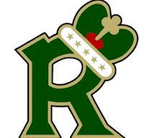
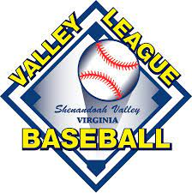
WINCHESTER ROYALS

Are you looking for an internship in the Sports Industry?
Are you a motivated, energetic, and driven individual?
Do you have a passion for baseball?

If so, then the Winchester Royals of the Valley Baseball League could be a great opportunity for you. We are a non-profit organization with a strong history of League Championships, multiple playoff berths, and numerous Major League Baseball draft picks. From the beginning of June through the end of July, we compete in a 42-game schedule up and down the Shenandoah Valley.

We are looking for interns that can assist us with our in-game entertainment, Social Media creations through graphics and video’s, pre- and post-game interviews, Play-by-Play, in-game music, and more. While this is not a paid internship, we can assist you with college credits that are approved through your school.

Anyone interested should send a letter of interest and resume to:
Executive Board Member / Coach
Rob Sikora
robert.sikora@lcps.org

